HTTP Request Packet : 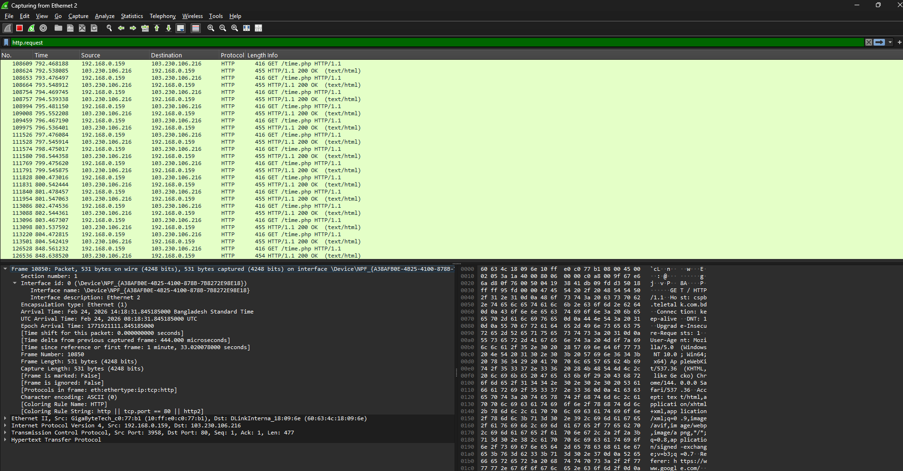
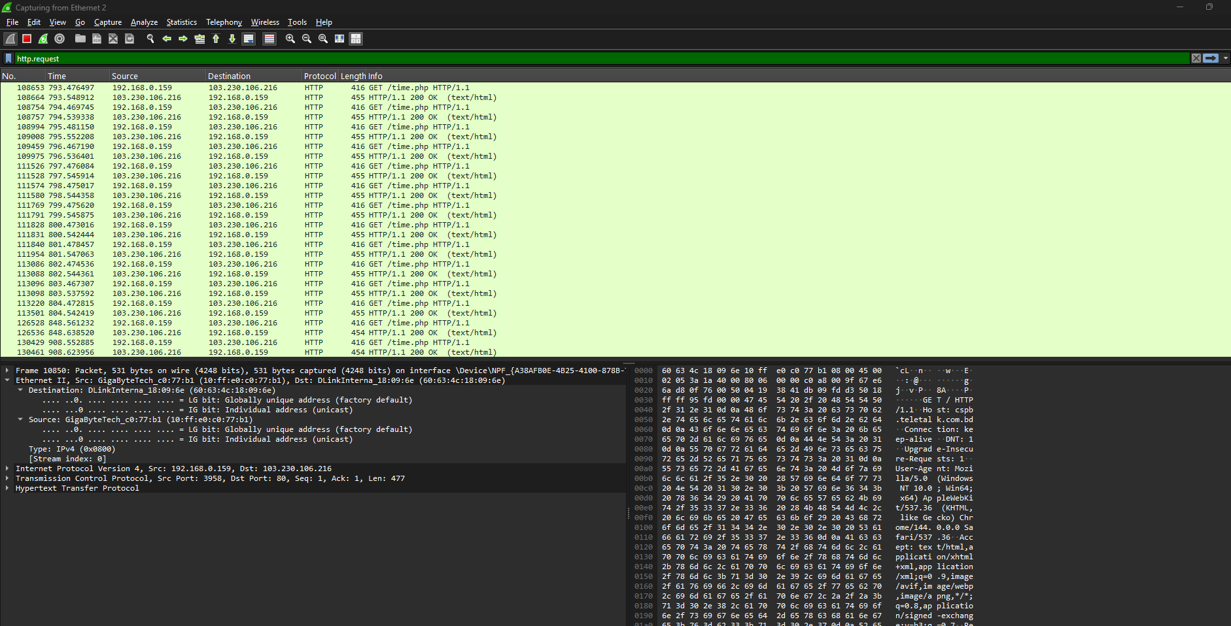
Ethernet II operates at the Data Link layer of the OSI or TCP/IP model, handling essential functions like framing, addressing, and error detection to maintain efficient and reliable communication between devices on a local network.
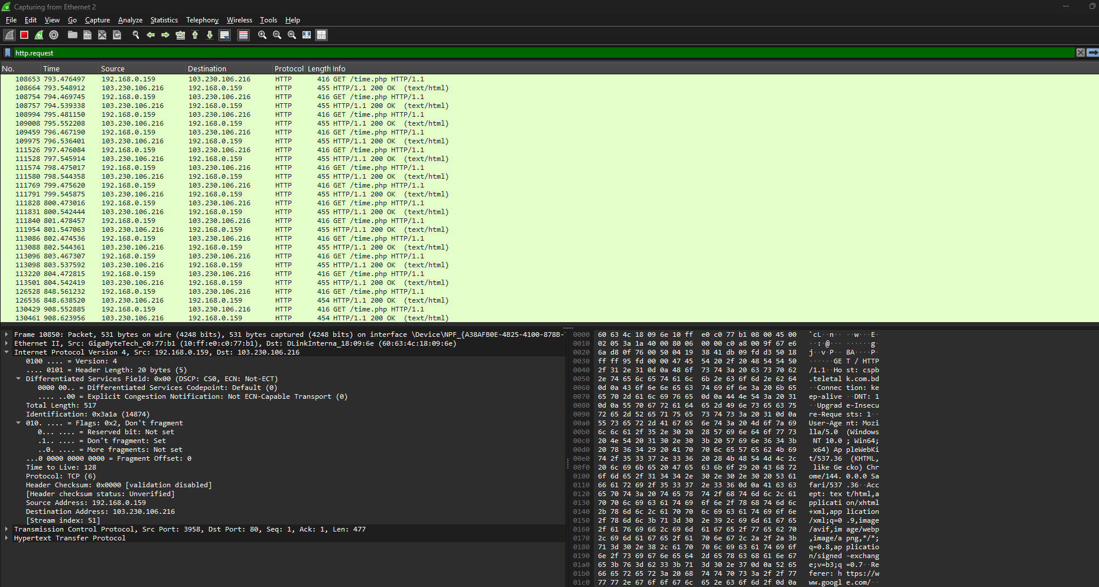
Internet Protocol Version 4 (IPv4) operates at the Network layer of the OSI or TCP/IP model, where it manages routing, addressing, and forwarding of data packets across interconnected networks.
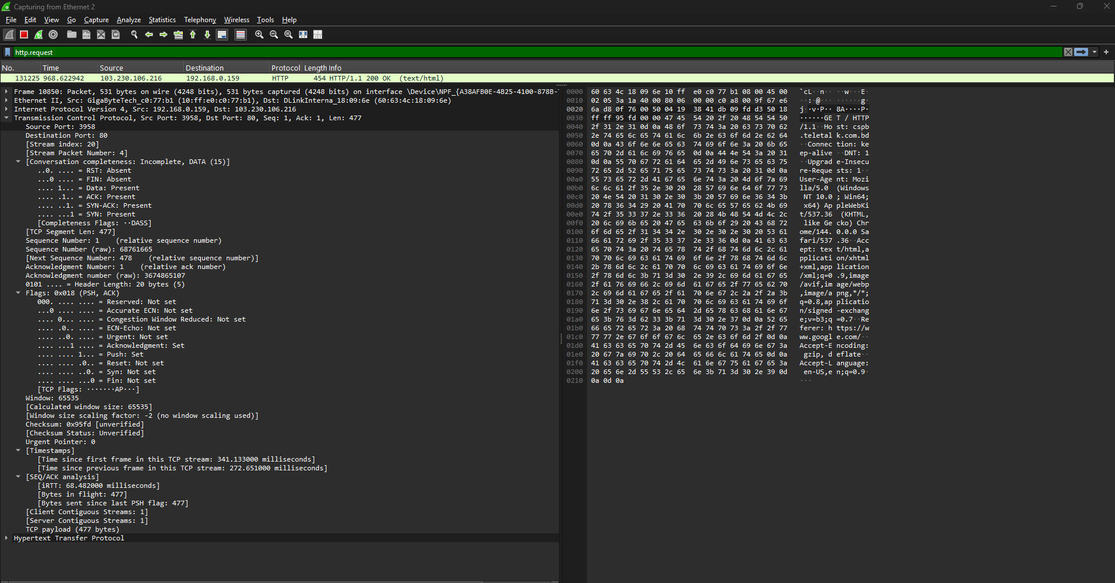
TCP (Transmission Control Protocol) functions at the Transport layer of the OSI or TCP/IP model, where it ensures reliable communication between devices. It uses a three-way handshake process to synchronize connections and confirm acknowledgements from both ends.
Source Port: 2389
Destination Port: 80
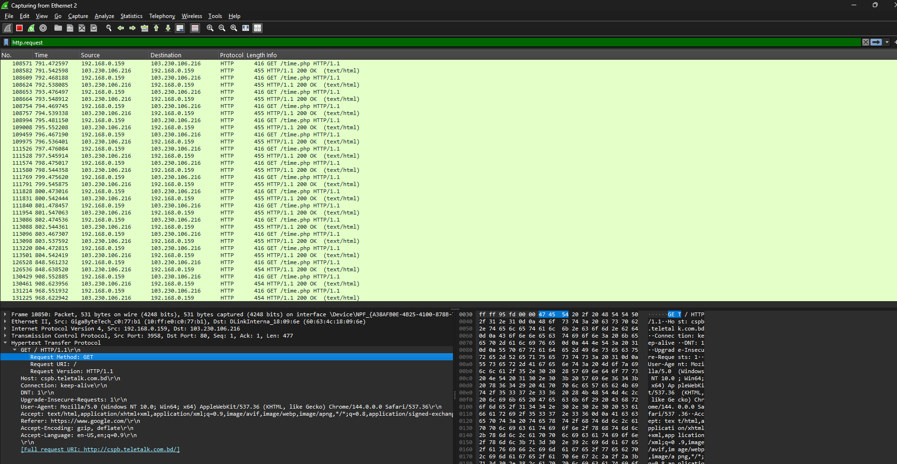
HTTP (Hypertext Transfer Protocol) operates at the Application layer of the OSI or TCP/IP model. In this case, the website ‘cspb.teletalk.com.bd’ was entered into the browser’s address bar, triggering a GET request to that host. The connection is marked as ‘keep-alive’, indicating a persistent HTTP connection that allows multiple requests and responses over the same session.
HTTP Response Packet :
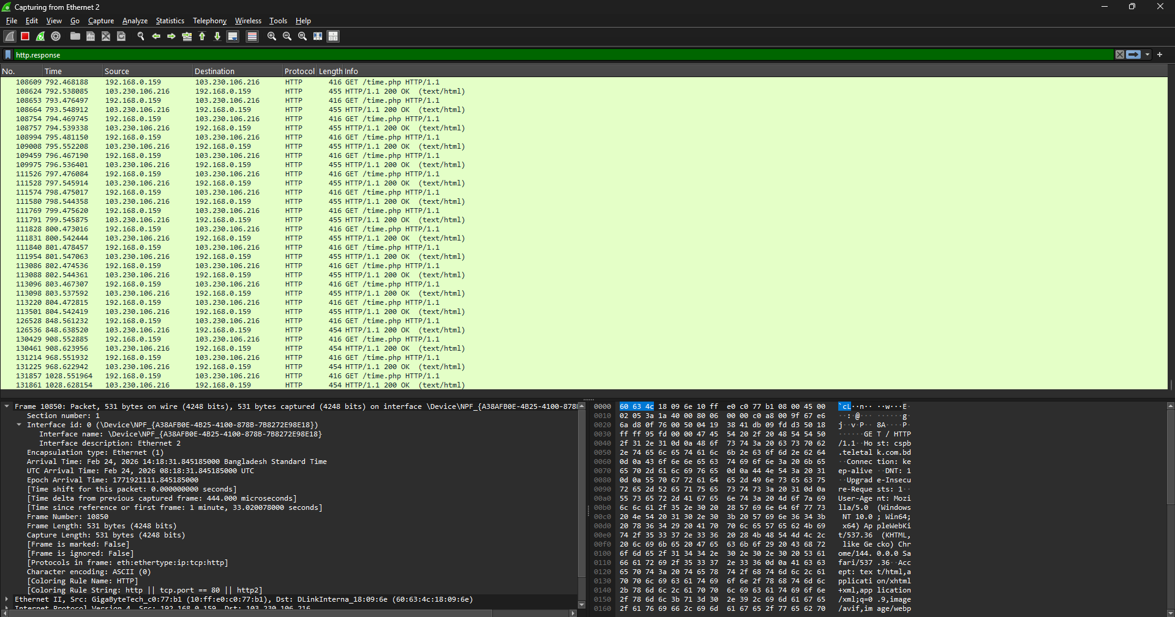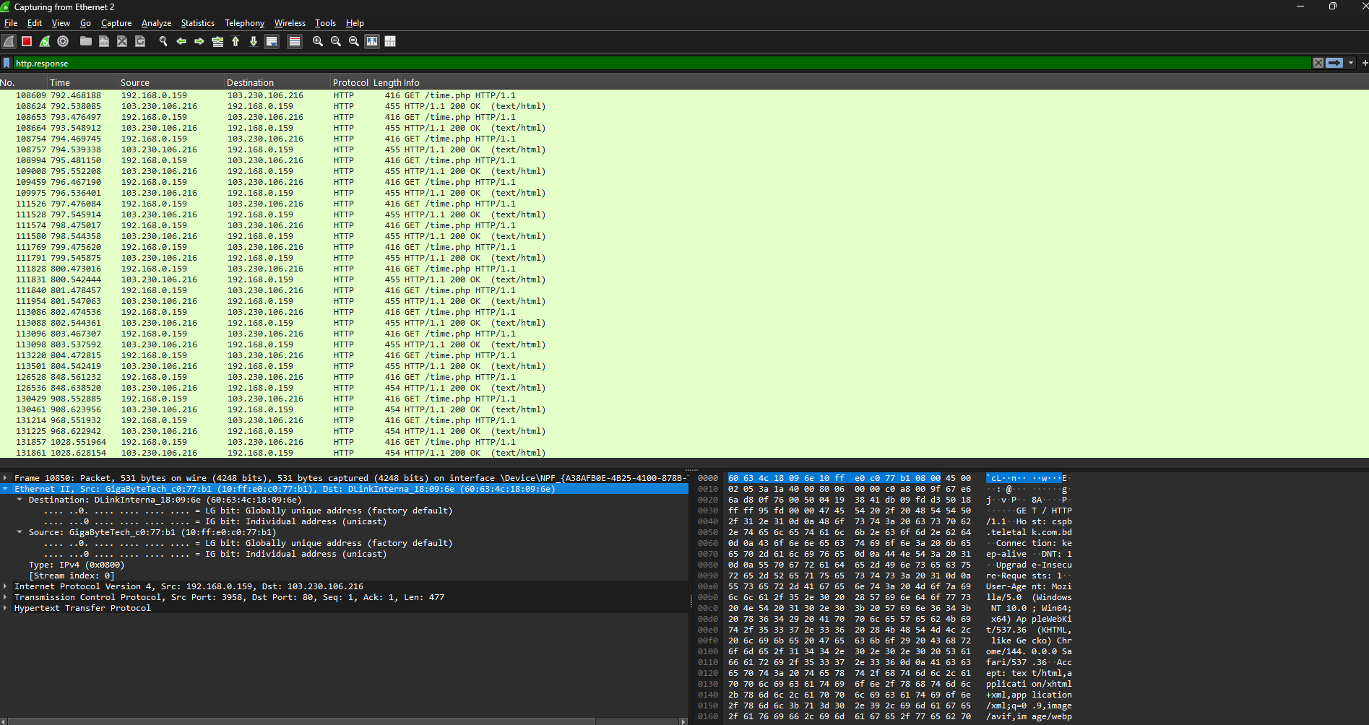
Ethernet II functions at the Data Link layer of the OSI or TCP/IP model, where it performs essential tasks such as framing, addressing, and error detection to ensure smooth and reliable communication between devices on a local network.
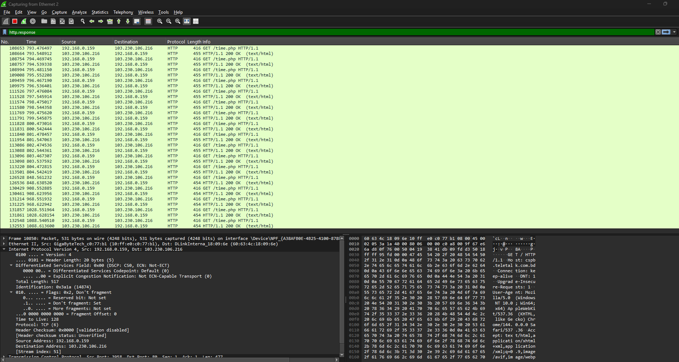
Internet Protocol Version 4 (IPv4) operates at the Network layer of the OSI or TCP/IP model, where it is responsible for routing, addressing, and forwarding data packets across interconnected networks to ensure proper delivery between devices.
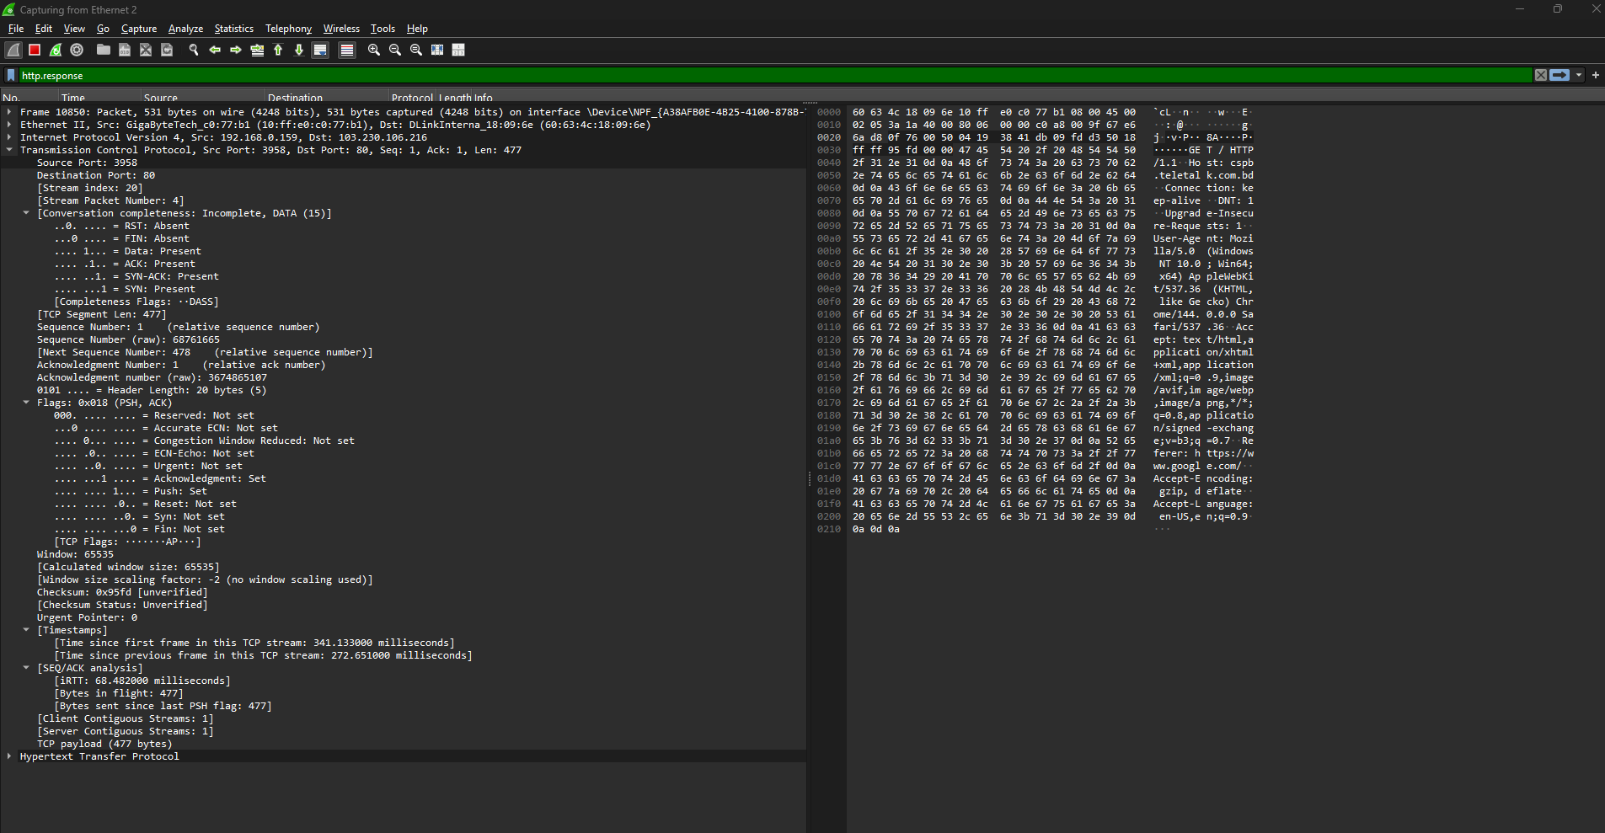
TCP (Transmission Control Protocol) functions at the Transport layer of the OSI or TCP/IP model, where it establishes reliable communication between devices. It uses a three-way handshake process to synchronize the connection and confirm acknowledgements from both ends.
Source Port: 80
Destination Port: 3958
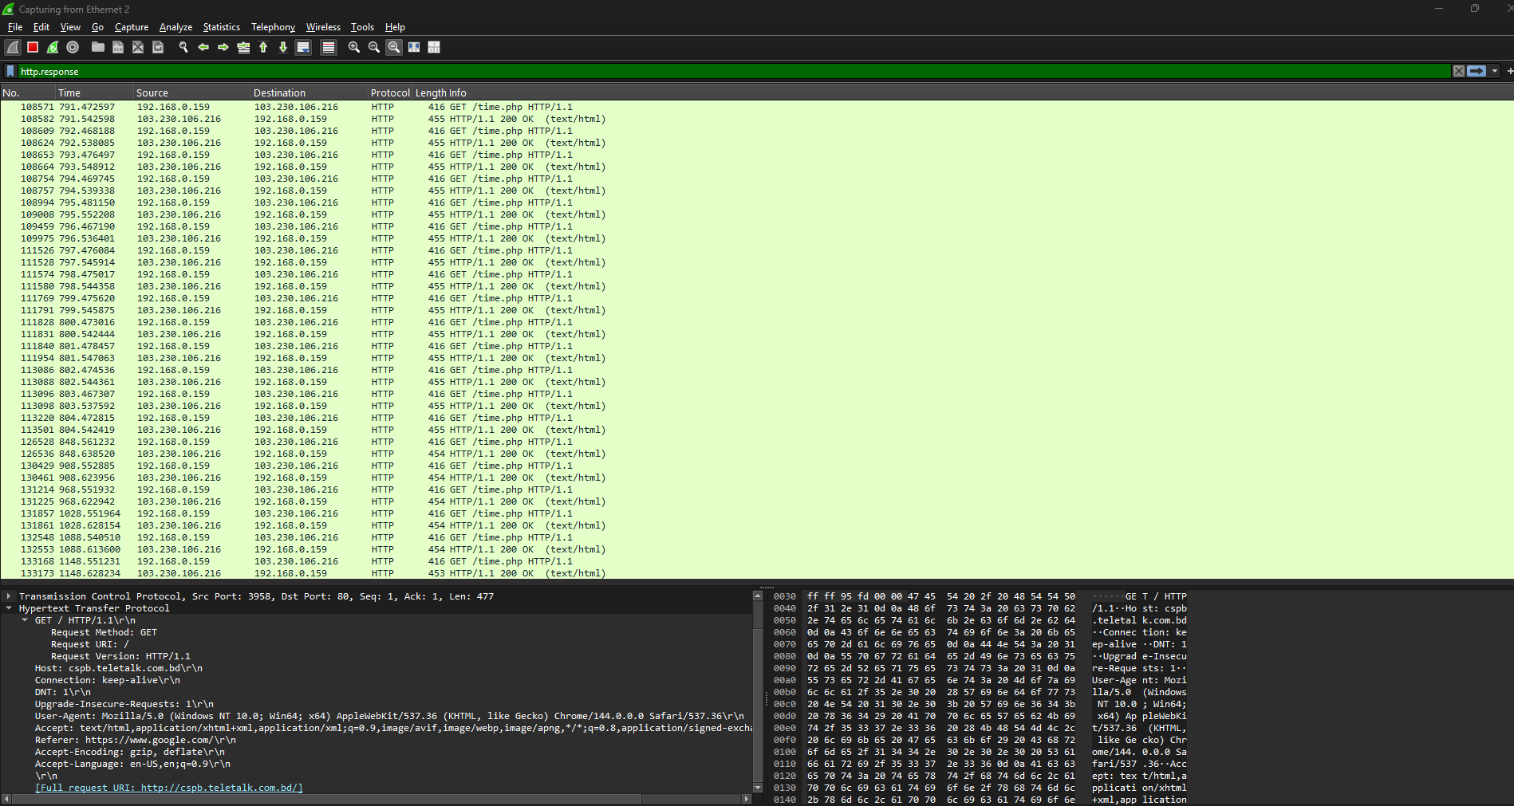
HTTP (Hypertext Transfer Protocol) operates at the Application layer of the OSI or TCP/IP model. When a URL is entered into the browser’s address bar, it initiates a request to the web server, which then sends a response back to the client device. The connection is marked as ‘keep-alive’, indicating a persistent HTTP session that allows continuous communication between the client and server.

